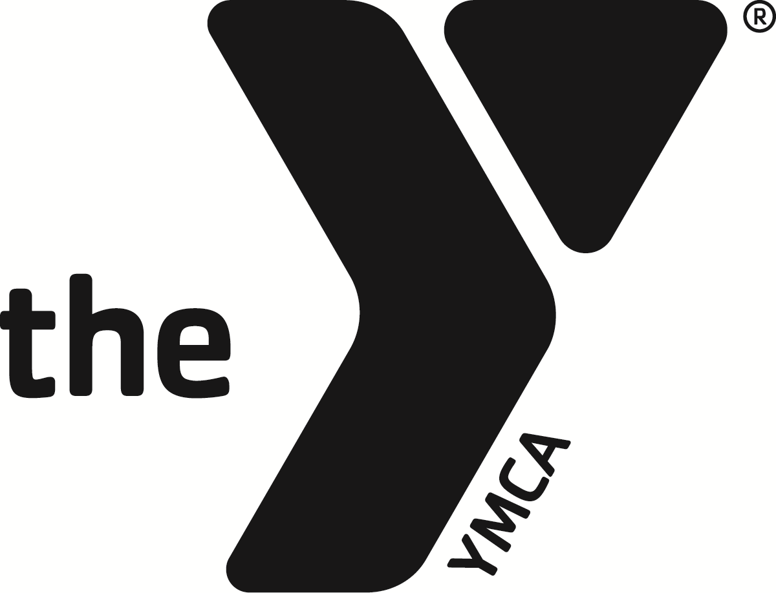 YMCA of CORSICANA

CAMP WANICA LIFEGUARD REQUEST

Pool rental requires: TWO (2) LIFEGUARDS up to 50 swimmers.
ONE (1) LIFEGUARD required for each additional 25 swimmers.

$_______ Two Lifeguards with Camp rental- $50 per hour. *Minimum of 2 hours*
Additional Lifeguard $20 per hour per lifeguard.

$_______ Two Lifeguards with Pool rental ONLY- $100 per hour. *Minimum of 2 hours*
Additional Lifeguard $20 per hour per lifeguard.

Name: ________________________________ Address: ___________________________

City: __________________________________ State_________ Zip: _______________

Group/Organization: ________________________________________________________

Phone #: ______________________________ Email: ____________________________

Camp Wanica Rental Date (s): ________________________________________

First Request Date: ______________________ Number of swimmers: _______

Pool Start Time: _____________ AM/PM End Time: ________ AM/PM

Second Request Date: ____________________ Number of swimmers: _______

Pool Start Time: _____________ AM/PM End Time: ________ AM/PM

I have read, understand and agree to the above stated rates and requirements.

_________________________________________ ______________________
Renter Signature Date

_________________________________________ ______________________
YMCA Representative Date

Please make all checks payable to: YMCA of Corsicana
Contact the YMCA at 903-872-2412 for any questions.

