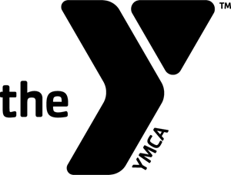
CORSICANA YMCA
AEROBICS ROOM SCHEDULE
EFFECTIVE STARTING September 11, 2023
TIME | MONDAY | TUESDAY | WEDNESDAY | THURSDAY | FRIDAY
7:45-8:00AM |  | POUND  Lanette |  | POUND  Lanette
8:00-9:00AM | YOGA  Helen |  | YOGA  Helen |  | YOGA  Helen
8:30-9:30AM |  | STEP  Laura H |  | STEP  Laura H
10:1511:00AM | GOLDEN & FIT Joy | GOLDEN & FIT Darlene | GOLDEN & FIT Joy | GOLDEN & FIT Darlene | GOLDEN & FIT Joy
5:15-6:00PM | AFC Joe | EXTEND Callee | AFC Joe | EXTEND Callee
6:00-6:45PM | ZUMBA Laura O | ZUMBA Laura O |  | ZUMBA Laura O
7:00-8:00PM |  | *SHOTOKAN KARATEDO | POWERPUMP Alley | *SHOTOKAN KARATEDO
CLASS DESCRIPTION
YOGA: Revitalize your body and mind by using stretching and breathing exercises.
POUND: Workout your entire body with high intensity choreographed drumming with weighted Ripstix.
GOLDEN & FIT: Designed for senior or low mobility members using chairs and low impact exercises.
STEP: Choreographed aerobics moving around and stepping on a low step bench.
ZUMBA: Cardio dance class that grooves to Latin inspired music.
POWERPUMP: Complete body workout with both hand weights and bar.
EXTEND: Cardio class that combines pilates and barre techniques for a unique and challenging experience.
Athletic Fitness Club: Cardio and strength training class to achieve your goals with programs and exercises designed to keep you motivated and consistent.
*SHOTOKAN KARATEDO: Add-on karate program for ages 7 through adults taught by Ben Vinson. See front desk for details.

