TIME | MONDAY | TUESDAY | WEDNESDAY | THURSDAY | FRIDAY
5:15-6:00AM | CYCLE & STRENGTH  Evelyn  *SPIN STUDIO |  | CYCLE & STRENGTH  Evelyn  *SPIN STUDIO
5:15-6:00am |  | METCON  Amber |  | METCON  Amber
8:30:9:15AM | TABATA  Whitney | HIIT  Callee | TABATA  Whitney | HIIT  Callee | HIIT  Whitney/  Callee
AFTERNOON
5:15-6:00PM | BOOST Jarod | CYCLE & STRENGTH  Casey  *SPIN STUDIO | BOOST Jarod | CYCLE & STRENGTH  Casey  *SPIN STUDIO
6:00-6:45PM | CYCLE & STRENGTH  Evelyn  *SPIN STUDIO |  | CYCLE & STRENGTH  Evelyn  *SPIN STUDIO
7:00-8:00PM | HIIT  Alley |  |  | HIIT  Alley
CLASS DESCRIPTION
CORE CYCLE: Intense spin for cardio with a focus on abs incorporated.
METCON: Strengthen and elevate your heartrate by rotating through timed stations and exercises.
TABATA: Whole body workout that includes 20 seconds of training followed by 10 seconds of rest for 2 minutes intrevals.
BOOST: Try the SuperFunctional system to maximize your workout. Each tri-plex system is based on a different category of movement to burn calories and strengthen.
CYCLE & STRENGTH: Spin cardio with a focus on upper body strength training.
HIIT: Complete body workout with both hand weights, bars, and cardio moves for high intensity interval training.

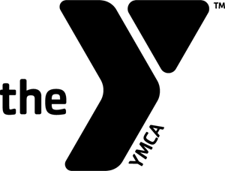
CORSICANA YMCA EFFECTIVE: August 21, 2023
QUEENAX ROOM & SPIN STUDIO SCHEDULE

